Lab Environment
Component | Version
Ubuntu | 24.04 LTS
Kubernetes | k3s Latest
Helm | Latest
New Relic | Free Account
Nodes | 1 Master + 1 Worker
Application | NGINX + BusyBox + Stress + NodeJS

LAB 1 : Environment Setup
Objective
Build a Kubernetes cluster that will be monitored by New Relic.

Architecture
New Relic Cloud
|
HTTPS (443)
|
------------------------------
| |
Master Node Worker Node
Ubuntu 24.04 Ubuntu 24.04
k3s Server k3s Agent

Lab Requirements
Machine | RAM | CPU | Disk
Master | 2 GB | 2 | 20 GB
Worker | 2 GB | 2 | 20 GB

Security Group
Allow
22
6443
80
443

LAB 2 : Install Master Node
Login
ssh ubuntu@MASTER_IP

Update Server
sudo apt update
sudo apt upgrade -y

Check OS
cat /etc/os-release
Expected
Ubuntu 24.04 LTS

Install k3s
curl -sfL https://get.k3s.io | sh -

Check Service
sudo systemctl status k3s
Expected
active (running)

Configure kubectl
mkdir -p ~/.kube
sudo cp /etc/rancher/k3s/k3s.yaml ~/.kube/config
sudo chown $(id -u):$(id -g) ~/.kube/config

Verify
kubectl get nodes
Expected
NAME STATUS ROLES
master Ready control-plane

- What is k3s
- Why use k3s
- Difference between Kubernetes and k3s

LAB 3 : Add Worker Node
Login
ssh ubuntu@WORKER_IP

Install Agent
First get token from Master
sudo cat /var/lib/rancher/k3s/server/node-token
Example
K10xxxxxxxxxxxxxxxx

Find Master IP
hostname -I
Suppose
172.31.4.105

Install Worker
curl -sfL https://get.k3s.io | \
K3S_URL=https://172.31.4.105:6443 \
K3S_TOKEN=<TOKEN> \
sh -

Go back to Master
kubectl get nodes
Expected
NAME STATUS
master Ready
worker1 Ready

LAB 4 : Deploy Sample Application
Create Deployment
kubectl create deployment nginx \
--image=nginx
Scale
kubectl scale deployment nginx \
--replicas=3
Verify
kubectl get pods -o wide

LAB 5 : Install Helm
Check
helm version
If not installed
curl https://raw.githubusercontent.com/helm/helm/main/scripts/get-helm-3 | bash
Verify
helm version
Expected
Version v3.x.x
Explain
- What is Helm?
- What is Chart?
- Why use Helm?

LAB 6 : Create New Relic Free Account
Open
https://newrelic.com/signup
Create account.
Verify email.
Login.

Explore Dashboard
Observe
Home
Infrastructure
Kubernetes
APM
Dashboards
Alerts
Logs
Integrations
Query Builder

Generate License Key
Open
Administration
↓
API Keys
↓
key type: license
License Keys
Copy License Key.
Explain
Difference between
License Key
User Key
Personal API Key
Only License Key is used by Infrastructure Agents.

LAB 7 : Install New Relic
Add Helm Repo
helm repo add newrelic https://helm-charts.newrelic.com
Update
helm repo update
Search
helm search repo newrelic
Explain available charts.

Create Namespace
kubectl create namespace newrelic

Create Secret
kubectl create secret generic newrelic-license \
--from-literal=licenseKey=<YOUR_LICENSE_KEY> \
-n newrelic
Verify
kubectl get secrets -n newrelic

Install Bundle
helm install newrelic-bundle newrelic/nri-bundle \
--namespace newrelic \
--set global.customSecretName=newrelic-license \
--set global.customSecretLicenseKey=licenseKey \
--set global.cluster=demo-cluster \
--set logging.enabled=true \
--set kubeEvents.enabled=true \
--set prometheus.enabled=true

Verify Installation
kubectl get pods -n newrelic
Expected
Running
newrelic-logging
nri-prometheus
nrk8s-controlplane
nrk8s-kubelet
nrk8s-ksm

Verify DaemonSet
kubectl get ds -n newrelic
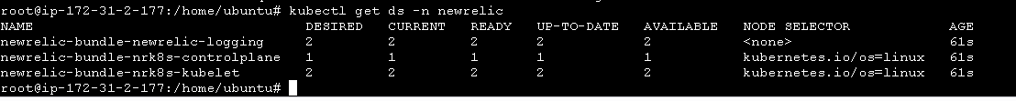

Verify Deployment
kubectl get deploy -n newrelic

Check Logs
kubectl logs -n newrelic \
-l app.kubernetes.io/name=newrelic-logging

LAB 8 : Verify Data is Reaching New Relic
Wait 2–5 minutes after installation.
Open the New Relic UI and navigate to:
Infrastructure
↓
Kubernetes
↓
Clusters
Verify that your cluster (demo-cluster) appears.
Then explore:
- Nodes
- Namespaces
- Deployments
- Pods
- Containers
Open a node and verify you can see:
- CPU utilization
- Memory utilization
- Network activity
- Disk usage
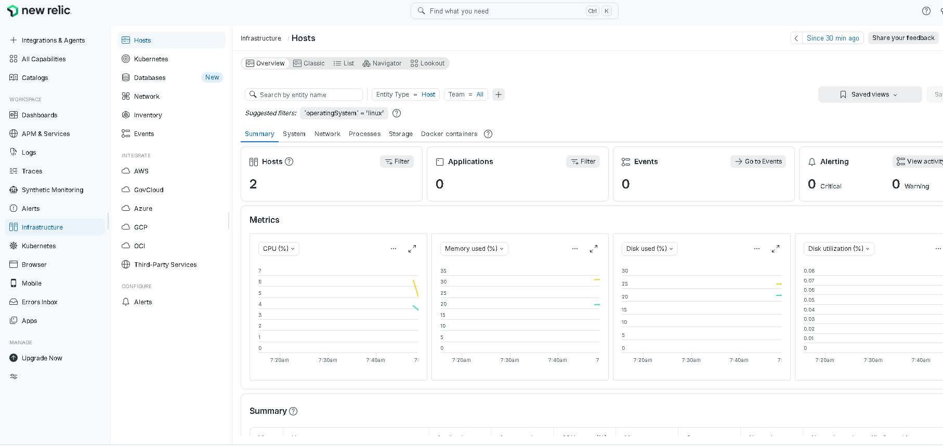

Lab 10:
Pod Monitoring
kubectl create deployment apache --image=httpd
kubectl scale deployment apache --replicas=5
Verify
kubectl get pods -o wide
Open
Kubernetes
↓
Pods
Observe
- Pod CPU
- Pod Memory
- Pod Restarts
- Pod Status
- Namespace
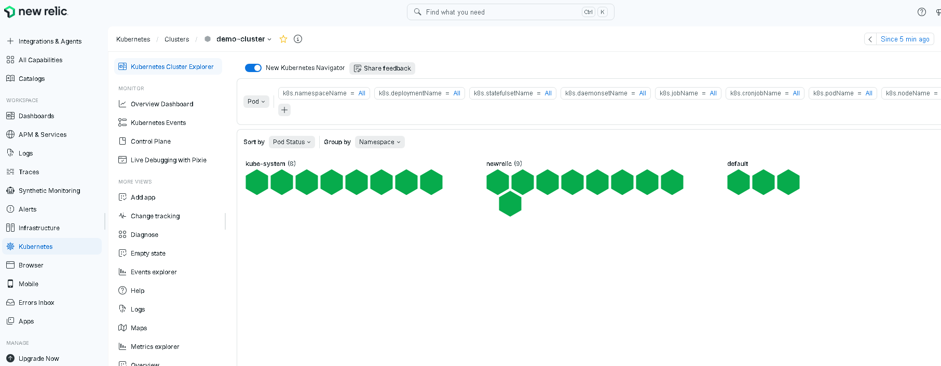

Lab 11 - Namespace Monitoring
Create Namespace
kubectl create namespace production
Deploy nginx
kubectl create deployment nginx \
--image=nginx \
-n production
Open
Namespaces
Observe
- Namespace Resource Usage
- Number of Pods
- CPU
- Memory
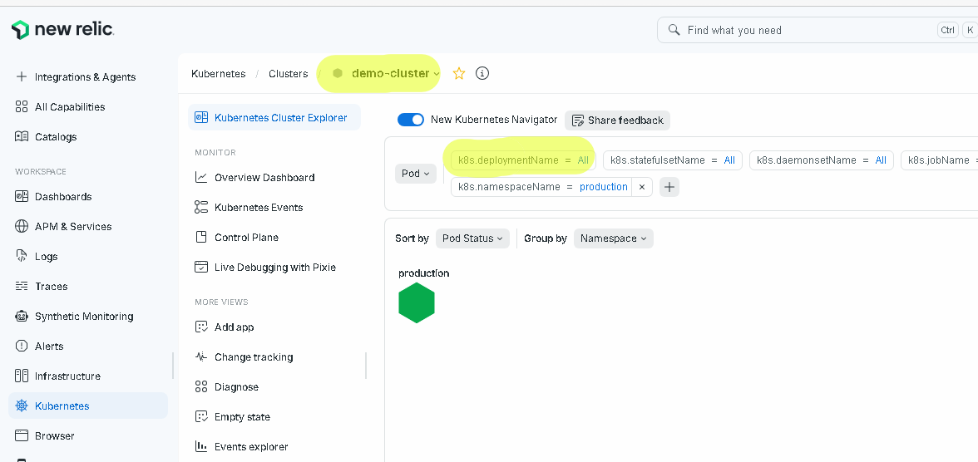
### SEND ALERT
LAB 12: Create a CPU Alert in New Relic
Objective
Create an alert that sends an email when CPU usage exceeds 20%.
Note: Use a low threshold like 20% in the lab so it triggers quickly. In production, you would typically use 80–90%.

Step 1: Open Alerts
Go to:
Alerts & AI
↓
Alert Conditions
Write your own query

Click
+ Create a policy

Step 2: Create Policy
Name
Kubernetes Monitoring Policy
Click
Create Policy

Step 3: Create Condition
Click
Add Condition
Choose
NRQL

Step 4: Enter NRQL Query
FROM SystemSample
SELECT average(cpuPercent)
FACET hostname
Click
Run Query
You should see your node's CPU graph.
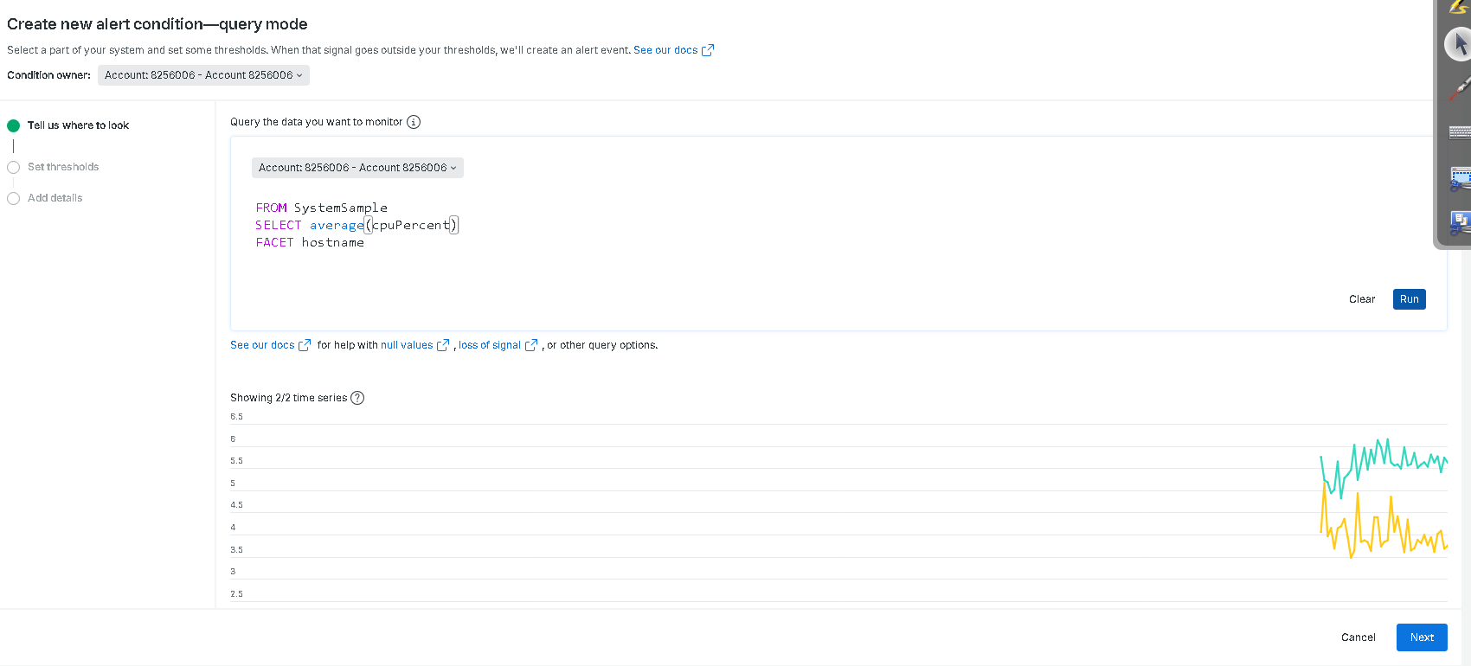

Step 5: Configure Threshold
Next
Scroll down
Signal
Static Threshold
Condition
Above 20
Duration
For at least 1 minute
Evaluation Delay
None

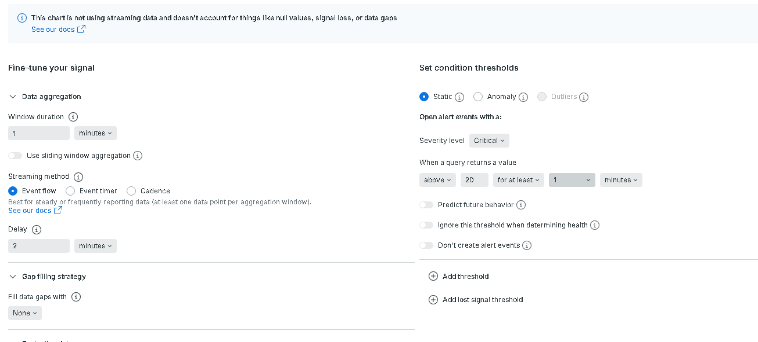

Step 6: Name the Condition
High CPU Usage
Save.

Step 7: Create Notification
Go to
Alerts & AI
↓
Destinations
Click
Create Destination
Select
Email
Enter
your-email@example.com
Verify the email.

Step 8: Create Workflow
Go to
Alerts & AI
↓
Workflows
↓
Create Workflow
Workflow Name
CPU Alert Workflow
Destination
Email
Policy
Kubernetes Monitoring Policy
Save.

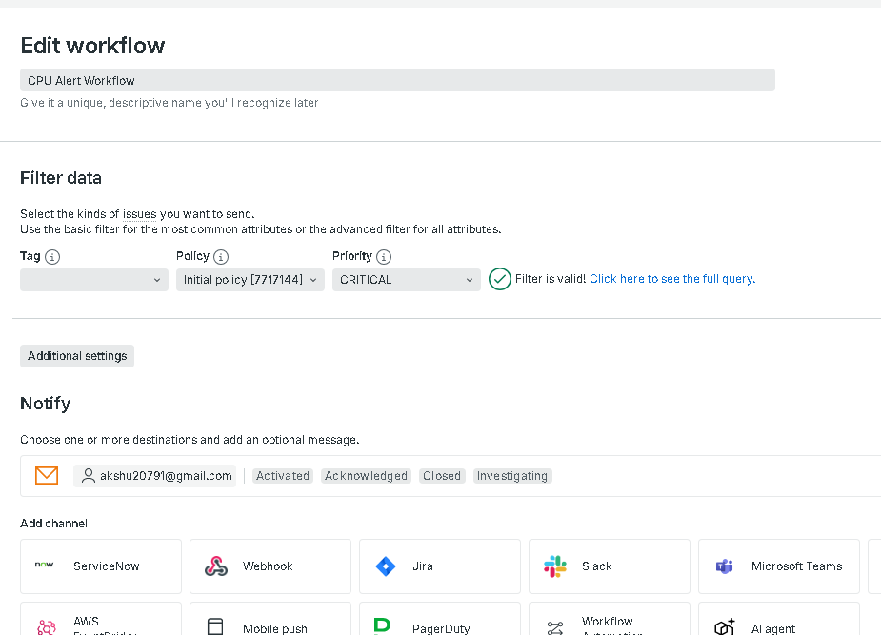

Step 9: Generate CPU Load
Create this pod.
apiVersion: v1
kind: Pod
metadata:
name: cpu-stress
spec:
containers:
- name: stress
image: polinux/stress
command:
- stress
args:
- "--cpu"
- "2"
- "--timeout"
- "600"Apply
kubectl apply -f cpu-stress.yaml

Step 10: Verify CPU
Run
kubectl top nodes
or
kubectl top pods
CPU should increase.

Step 11: Observe in New Relic
Open
Infrastructure
↓
Nodes
CPU graph should rise.

Step 12: Receive Email
After approximately 1–3 minutes, you should receive an email similar to:
Incident Opened
Policy:
Kubernetes Monitoring Policy
Condition:
High CPU Usage
Hostname:
worker1
CPU:
38%

Cleanup
Delete the stress pod.
kubectl delete pod cpu-stress
Once CPU drops below the threshold, New Relic will automatically close the incident, and if your workflow is configured to notify on closure, you'll receive a recovery notification as well.

More Alert Labs for Your Students
Lab 1: High CPU Alert
Generate CPU load using a stress pod.

Lab 2: High Memory Alert
Deploy:
args:
- "--vm"
- "1"
- "--vm-bytes"
- "800M"
Create an alert on:
FROM SystemSample
SELECT average(memoryUsedPercent)
FACET hostname
Threshold
Above 30%

Lab 3: Pod Restart Alert
NRQL
FROM K8sContainerSample
SELECT latest(restartCount)
FACET podName
Threshold
Above 2
Deploy a crashing pod to increase the restart count.

Lab 4: CrashLoopBackOff Alert
Deploy a pod that exits immediately.
command:
- /bin/sh
- -c
- exit 1
Create an alert using a suitable K8sContainerSample or K8sPodSample field (depending on the event types available in your account) to detect repeated restarts or unhealthy pod states.

Lab 5: Node Not Reporting
Simulate by stopping the k3s agent on a worker node:
sudo systemctl stop k3s-agent
Create a loss of signal alert so New Relic notifies you when the node stops sending telemetry.

Lab 6: Log-Based Alert
Generate repeated error logs:
kubectl run errorlog \
--image=busybox \
--restart=Never \
-- sh -c 'while true; do echo "ERROR Database Connection Failed"; sleep 5; done'
Create a log alert matching:
ERROR
Receive an email whenever matching log entries exceed your defined threshold.

